**SQL Exercise 8**

1. Display the Supplier table in the descending order of CITY.

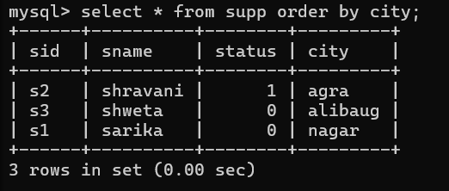

1. Display the Part Table in the ascending order of CITY and within the city in the ascending order of Part names

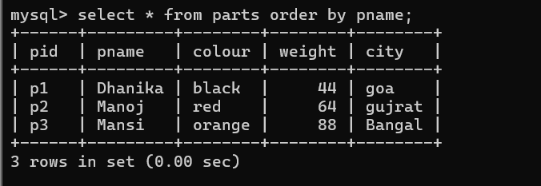

1. Display all the Suppliers with a status between 10 and 20.



1. Display all the Parts and their Weight, which are not in the range of 10 and 15.

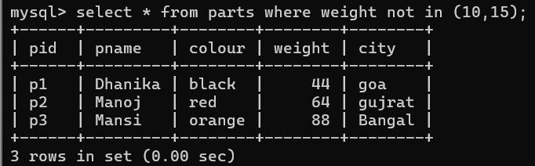

1. Display all the Part names starting with the letter ‘S’.

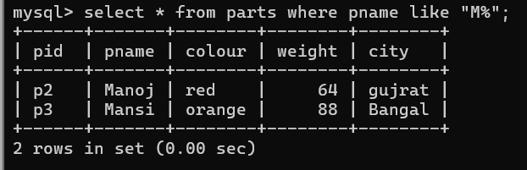

1. Display all the Suppliers, belonging to cities starting with the letter ‘L’.

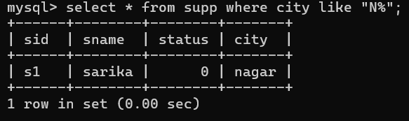

1. Display all the Projects, with the third letter in JNAME as ‘n’.



8.Display all the Supplier names with the initial letter capital.

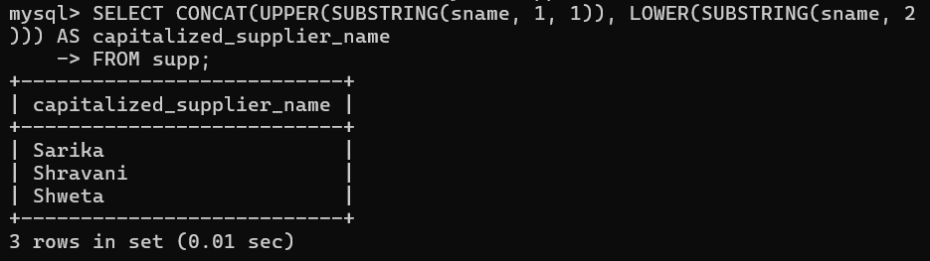

1. Display all the Supplier names in upper case.

select upper(sname) from supplier;

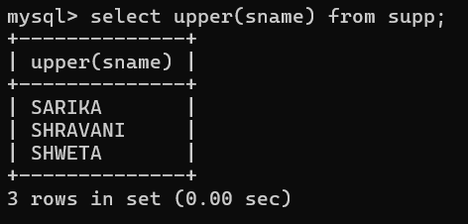

1. Display all the Supplier names in lower case.

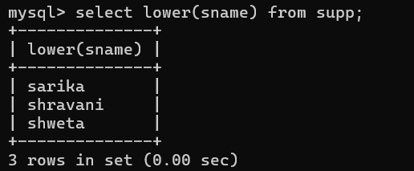

1. Display all the Supplier names padded to 25 characters, with spaces on the left.

select lpad(sname,25,' ') from supplier;

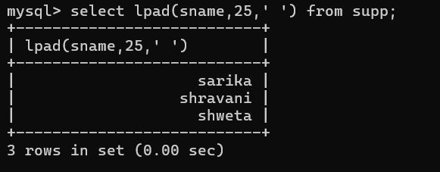

1. Display all the Supplier names (with ‘la’ replaced by ‘ro’).

HINT: REPLACE.

select sname,replace(sname,'ra','ro') ra_ro from supplier;

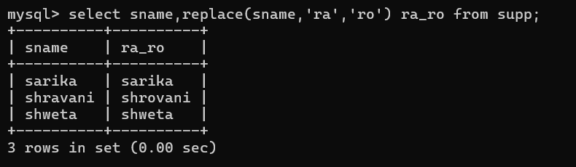

1. Execute the above command with the translate function and note the difference in output.

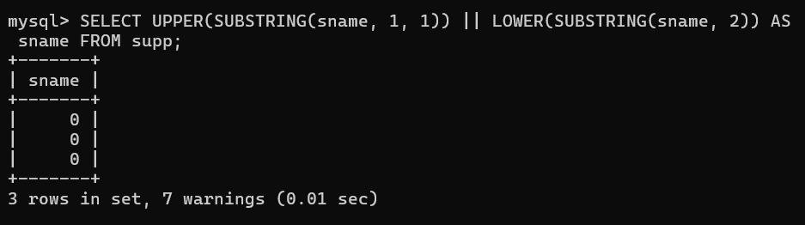

1. Display the Supplier names and the lengths of the names.

select sname, length(sname) from supplier;

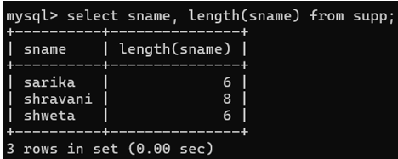

1. Use the soundex function to search for a supplier by the name of ‘BLOKE’.

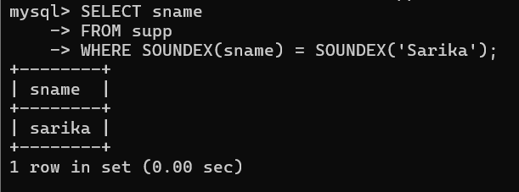

1. Display the Supplier name and the status (as Ten, Twenty, Thirty, etc.).

select sname, status from supplier;

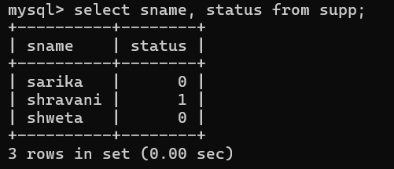

1. Display the current day (e.g. Thursday).

select dayname(curdate()) day;

